**EX.NO:6**

**DATE:11.09.2024**

# RESTRICTINGANDSORTINGDATA

Find the Solution for the following:

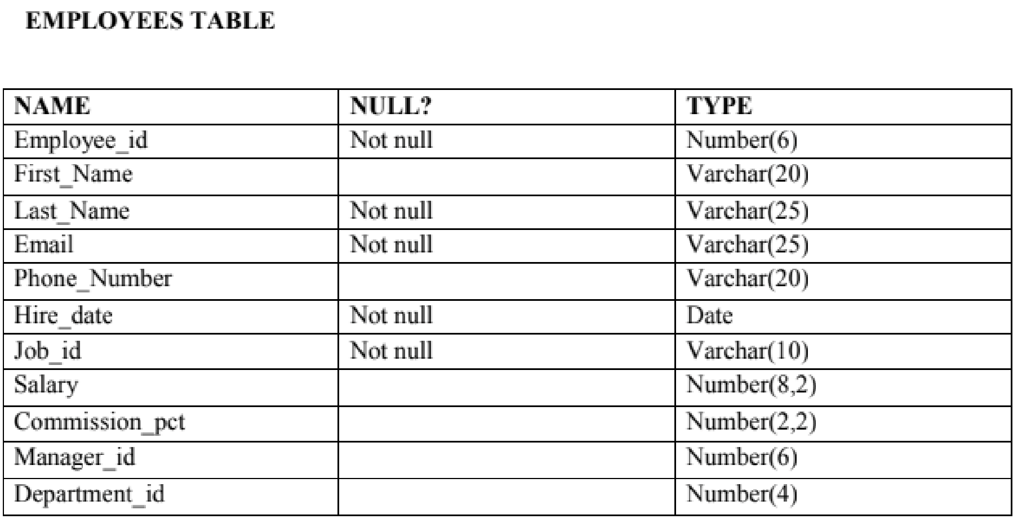

**CREATE TABLE Employees (**

**Employee_id NUMBER(6) NOT NULL,**

**First_Name VARCHAR(20),**

**Last_Name VARCHAR(25) NOT NULL,**

**Email VARCHAR(25) NOT NULL,**

**Phone_Number VARCHAR(20),**

**Hire_date DATE NOT NULL,**

**Job_id VARCHAR(10) NOT NULL,**

**Salary NUMBER(8,2),**

**Commission_pct NUMBER(2,2),**

**Manager_id NUMBER(6),**

**Department_id NUMBER(4)**

**);**

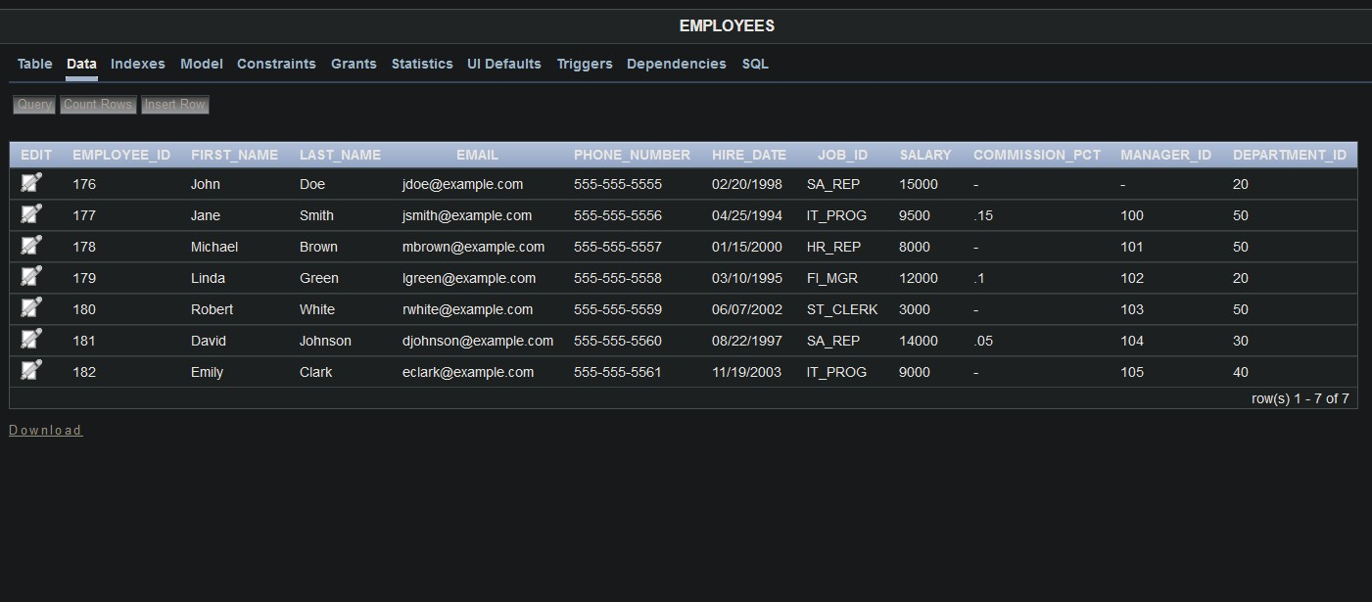

1. Create a query to display the last name and salary of employees earning more than 12000.

**SELECT Last_Name, Salary**

**FROM Employees**

**WHERE Salary > 12000;**

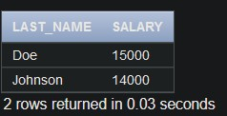

1. Create a query to display the employee last name and department number for employee number 176.

**SELECT Last_Name, Department_id**

**FROM Employees**

**WHERE Employee_id = 176;**

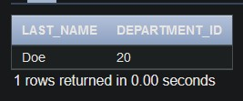

1. Create a query to display the last name and salary of employees whose salary is not in the range of 5000 and 12000. (hints: not between )

**SELECT Last_Name, Salary**

**FROM Employees**

**WHERE Salary NOT BETWEEN 5000 AND 12000;**

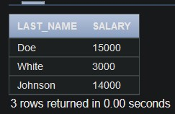

1. Display the employee last name, job ID, and start date of employees hired between February 20,1998 and May 1,1998.order the query in ascending order by start date.(hints:

between)

**SELECT Last_Name, Job_id, Hire_date**

**FROM Employees**

**WHERE Hire_date BETWEEN TO_DATE('20-FEB-1998', 'DD-MON-YYYY') AND**

**TO_DATE('01-MAY-1998', 'DD-MON-YYYY')**

**ORDER BY Hire_date ASC;**

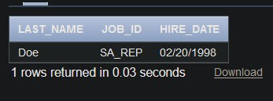

1. Display the last name and department number of all employees in departments 20 and 50 in alphabetical order by name.(hints: in, orderby)

**SELECT Last_Name, Department_id**

**FROM Employees**

**WHERE Department_id IN (20, 50)**

**ORDER BY Last_Name ASC;**

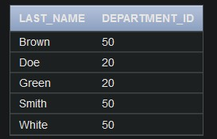

1. Display the last name and salary of all employees who earn between 5000 and 12000 and are in departments 20 and 50 in alphabetical order by name. Label the columns **EMPLOYEE, MONTHLY SALARY respectively.(hints: between, in)**

**SELECT Last_Name AS EMPLOYEE, Salary AS "MONTHLY SALARY"**

**FROM Employees**

**WHERE Salary BETWEEN 5000 AND 12000 AND Department_id IN (20, 50)**

**ORDER BY Last_Name ASC;**

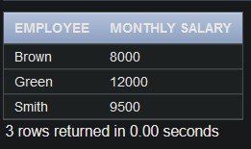

1. Display the last name and hire date of every employee who was hired in 1994.(hints: like)

**SELECT Last_Name, Hire_date**

**FROM Employees**

**WHERE Hire_date LIKE '%1994';**

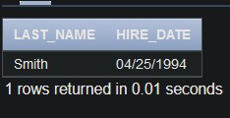

1. Display the last name and job title of all employees who do not have a manager.(hints: is null)

**SELECT Last_Name, Job_id**

**FROM Employees**

**WHERE Manager_id IS NULL;**

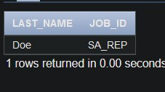

1. Display the last name, salary, and commission for all employees who earn commissions.

**Sort data in descending order of salary and commissions.(hints: is not nul,orderby)**

**SELECT Last_Name, Salary, Commission_pct**

**FROM Employees**

**WHERE Commission_pct IS NOT NULL**

**ORDER BY Salary DESC, Commission_pct DESC;**

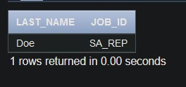

1. Display the last name of all employees where the third letter of the name is a.(hints:like)

**SELECT Last_Name**

**FROM Employees**

**WHERE Last_Name LIKE '__a%';**

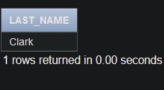

1. Display the last name of all employees who have an a and an e in their last name.(hints: like)

**SELECT Last_Name**

**FROM Employees**

**WHERE Last_Name LIKE '%a%' AND Last_Name LIKE '%e%';**



1. Display the last name and job and salary for all employees whose job is sales

representative or stock clerk and whose salary is not equal to 2500 ,3500 or 7000.(hints:in,not in)

**SELECT Last_Name, Job_id, Salary**

**FROM Employees**

**WHERE Job_id IN ('SA_REP', 'ST_CLERK')**

**AND Salary NOT IN (2500, 3500, 7000);**

